AZURE A LEARNING GUIDE

Ashok

[Email address]

Prepared: Ashoka Chakravarti Marpu

Senior Cloud Engineer

Table of Contents

What is Azure? 2

Azure is Responsible for 2

What is Azure Subscription? 3

What is an Azure account? 3

Azure Resource Group 5

Role Base Access Control 6

Azure Networking 7

IP support in Virtual network 7

Subnet 7

CIDR 7

Azure DNS 8

Azure Virtual Network (VNet) 9

Azure Firewall 10

Public Facing IPs 10

Azure Load Balancer 12

Traffic Manger 13

Availability set 14

Auto scaling 15

Azure Application Gateway 15

PaaS and Azure SQL database 16

Azure DDOs standard protection 16

Application Security Group 18

Virtual Applications 18

Network Peering 19

Point-to -Site VPN 20

Site -to -Site VPN 21

ExpressRoute 22

Network Monitoring Requirements 23

Azure Monitor 24

Azure Network Watcher 24

Azure Storage 24

Azure Disks 24

Storage Account 26

Blob: (Binary Large Objects) 27

Queue 27

File System 27

Tables 27

Microsoft Azure Site Recovery 27

Azure AD 30

Azure API 31

API Gateway 32

# **What is Azure?**

Microsoft Azure is an ever-expanding set of cloud services to help your organization meet your business challenges. It’s the freedom to build, manage, and deploy applications on a massive, global network using your favorite tools and frameworks.

Azure is Microsoft's cloud solution. A cloud is essentially a collection of host data centers that you don't have to directly manage. You can request services from that cloud

Cost, Global scale, performance, security, speed, productivity, Reliability.

### Azure is Responsible for

Availability of the platform (datacenter, connectivity, server, power cooling)

Data availability

Maintenance of the platform (datacenter, connectivity, server storage)

Physical security

Availability of the service (VM, storage, Network)

Azure is NOT responsible for

VM OS, Application deployment on the VM, Resource security

Customer are responsible for

VM maintenance & VM OS maintenance

Application availability

Backup and recovery &Configure the monitoring

User’s security, Configure the AD or other services

|  |  |  |  |  |
| --- | --- | --- | --- | --- |
| **Responsibility** | **On-prem** | **IaaS** | **PaaS** | **SaaS** |
| Data Governance &rights Management | Customer | Customer | Customer | Customer |
| Clients Endpoints | Customer | Customer | Customer | Customer |
| Account & Access Management | Customer | Customer | Customer | Customer |
| Identity & directory infrastructure | Customer | Customer | Microsoft/ Customer | Microsoft/ Customer |
| Application | Customer | Customer | Microsoft/ Customer | Microsoft |
| Network control | Customer | Customer | Microsoft/ Customer | Microsoft |
| Operating system | Customer | Microsoft | Microsoft | Microsoft |
| Physical Host | Customer | Microsoft | Microsoft | Microsoft |
| Physical network | Customer | Microsoft | Microsoft | Microsoft |
| Physical datacentre | Customer | Microsoft | Microsoft | Microsoft |
|  |  |  |  |  |

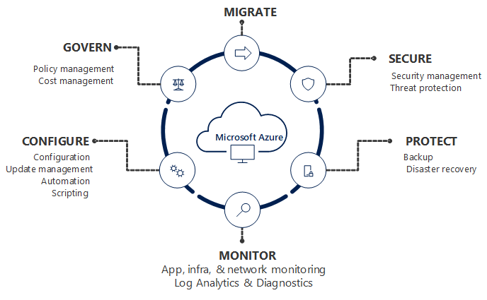

Govern: - Governance provides mechanisms and processes to maintain control over your applications and resources in Azure. It involves planning your initiatives and setting strategic priorities. Governance in Azure is primarily implemented with two services. Azure Policy allows you to create, assign, and manage policy definitions to enforce rules for your resources. This feature keeps those resources in compliance with your corporate standards. Azure Cost Management allows you to track cloud usage and expenditures for your Azure resources and other cloud providers.

### What is Azure Subscription?

* A subscription is a logical unit of Azure services that is linked to an Azure account. Each associated account has a role in a subscription. Billing for Azure services is done on a per-subscription basis.
* A Microsoft Azure subscription grants you access to Azure services and to the Microsoft Azure Platform Management Portal.
* Azure subscription is billing container for deployed Microsoft Azure Services
* We can deploy our IaaS, PaaS, SaaS application (web apps VM storage account network DR etc.)
* Azure Subscription has trusted relationship with Azure AD
* All the users, service, and devices authentication from Azure AD

[Introduction to Azure Enterprise and Subscription Management](https://blogs.msdn.microsoft.com/azureedu/2016/10/29/introduction-to-azure-enterprise-and-subscription-management/)

**Billing account**

* Represents a single owner (Account administrator) for one or more Azure subscriptions. An Account Administrator is authorized to perform various billing tasks like create subscriptions, view invoices or change the billing for subscriptions.

**Subscription**

* Represents a grouping of Azure resources. An invoice is generated at the subscription scope. It has its own payment methods that are used to pay its invoice.

### What is an Azure account?

**Account Administrator:** 1 per Azure account

* Access the Azure Account Center
* Manage all subscriptions in an account
* Create new subscriptions
* Cancel subscriptions
* Change the billing for a subscription
* Change the Service Administrator
* **Note:** Conceptually, the billing owner of the subscription.

The Account Administrator has no access to the Azure portal.

**Service Administrator**: 1 per Azure subscription

* Manage services in the Azure portal
* Cancel the subscription
* Assign users to the Co-Administrator role
* By default, for a new subscription, the Account Administrator is also the Service Administrator.
* The Service Administrator has the equivalent access of a user who is assigned the Owner role at the subscription scope.
* The Service Administrator has full access to the Azure portal.
* **Note:** By default, for a new subscription, the Account Administrator is also the Service Administrator. The Service Administrator has the equivalent access of a user who is assigned the Owner role at the subscription scope. The Service Administrator has full access to the Azure portal.

**Co-Administrator:** 200 per subscription

* Same access privileges as the Service Administrator, but can’t change the association of subscriptions to Azure directories
* Assign users to the Co-Administrator role, but cannot change the Service Administrator

**Note:** The Co-Administrator has the equivalent access of a user who is assigned the Owner role at the subscription scope.

Azure Enterprise

Any Enterprise Agreement customer can add Azure to their agreement by making an upfront monetary commitment to Azure. That commitment is consumed throughout the year by using any combination of the wide variety of cloud services Azure offers from its global datacenters

Azure Enterprise Agreement Benefits

1. **An EA is better for managing teams**
2. **An EA provides discounts**
3. **An EA helps with cash flow management**
4. **An EA gives you access to unique Azure features**
5. Pay for additional usage beyond the commitment, at the same rates.

Azure EA admin Accounts

Enterprises enrollment

* The enterprises enrollment defines the shape and use of azure services with a company and is the core governance structure
* Within the enterprise’s agreement customer can further subdivide the environment into department accounts and finally subscription
* Enterprises admin can add or associate accounts to the enrolment, can view usage data across all accounts

[Organize your resources with Azure Management Groups](https://docs.microsoft.com/en-us/azure/azure-resource-manager/management-groups-overview)

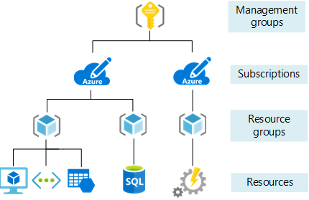

Manage Subscription with Portal

Use Subscriptions page to:

View and edit subscription details

Usage and billing information

View and edit profile

Change payment method

Cancel subscription

Enable preview features

### Azure Resource Group

* Container for resource
* Logical grouping of resource of similar purpose
* Allows to delegate permission
* No costing is monitoring, or bill generate specific to location
* Sub-component under subscription
* Requires at least on resource group to create resource or consume resource

### Role Base Access Control

RBAC provides fine-grained access management to your resources in Azure

Using RBAC, you can segregate duties within your team and grant only the amount of access to users that they need to perform their jobs. Instead of giving everybody unrestricted permissions in your Azure subscription or resources, you can allow only certain actions at a particular scope

Role-based access control can be used to assign permissions to:

* Users
* Groups
* Application

Scope: -

What level these permissions will apply

The scope of role assignment can be:

* Subscription
* Resource group
* Single resource
* Management group level

Here are some examples of what you can do with RBAC:

* Allow one user to manage virtual machines in a subscription and another user to manage virtual networks
* Allow a DBA group to manage SQL databases in a subscription
* Allow a user to manage all resources in a resource group, such as virtual machines, websites, and subnets
* Allow an application to access all resources in a resource group

**Owner** has full access to all resources including the right to delegate access to other users.

**Contributor** has full access to all resources but can’t delegate control to other users.

**Resource Policy Contributor** can create and manage policies in the directory on the resources.

**Reader** can view existing Azure resources

* Provide exact permission to user or group
* Grant access by assigning the appropriate RBAC role
* Can use built-in role or create custom role
* We ca grant to access at subscription level
* We can give the access at resource group
* We can grant the access for specific site

### View Activity logs for RBAC changes

**The Azure Activity log** provides visibility into subscription-level events that have occurred in Azure

You can determine what operations were taken on the resources in your subscription

The Activity log has eight categories

Administrative: this contains all the records for create, update, delete, and action operations performed. Here we will see events related to RBAC

Service Health: This contains any health-related events that affect Azure.

Resource health: This contains that record of any resource health events that have occurred to your deployed resources in Azure

Alert: This contains all the alerts that have been activated

Autoscale: This includes all the record of events related to Autoscale.

Recommendation: this contains recommendation events from azure advisor

Security: This contains the record of any alerts generated by Azure security center

Policy: This contains records of all effect action operations performed by Azure policy

# **Azure Networking**

### IP support in Virtual network

* IPV4 today
* TCP, UDP, and ICMP
* No multicast, broadcast GRE protocols or IP-in-IP packets
* IPV6 in the future
* VM always get the IP address via DHCP in azure (unless using multiple IPs on a VM nic)
* Never try and assign a static IP unless mandatory otherwise it will break at some points
* When a VM re-provisioned to the fabric it gets a new vmNIC and possibly a new IP.
* Static IP can be assigned via the Azure fabric using portal, PowerShell and CLI
* Create a separate subnet as the pool for static IP assignment.

### Subnet

* A subnet is a range of IP address in the VNet. You can divide a VNet into multiple subnets.
* VM deployed to subnets (same or different) with in a VNet can communicate each other without any extra configuration
* You can also configure route tables and NSG to subnet
* Within each subnet, the first three IP address and last IP address are reserved and can be not used for VMs, the smallest subnets are supported to use a 29-bit subnet mask
* First and last reserved per protocol for host id and broadcast.
* The 1st three IP address are reserved binary 01, 10 and 11 in the host ID portion of the IP address
* We can add more address spaces.
* Azure reserves 5 IP addresses within each subnet. These are x.x.x.0-x.x.x.3 and the last address of the subnet. x.x.x.1-x.x.x.3 is reserved in each subnet for Azure services.
* x.x.x.0: Network address
* x.x.x.1: Reserved by Azure for the default gateway
* x.x.x.2, x.x.x.3: Reserved by Azure to map the Azure DNS IPs to the VNet space
* x.x.x.255: Network broadcast address

### CIDR

* Class less Inter – Domain Routing
* CIDR way to represent network IP block. The length of the network prefix in IPv4 CIDR is specified as part of the IP address.
* For example: 192.30.250.0/24 the 192.30.250.0 is the network address it self and the “24” says that the first 24 bit are the network part of the address. Leaving the last 8 bit for specific host address
* CIDR notation is a compact representation of an IP address and its associated routing prefix.
* The notation is constructed from an IP address, a slash (“/”) character and a decimal number. The number is the count of leading 1 bit in the routing mask traditionally called the network mask
* Used in virtual network configuration combing the IP address and it associate network mask
* XXX.XXX.XXX.XXX/N
* XXX.XXX.XX.XXX/ IP address
* N is the number of bits used for subnet mask E.g. 24 would equal to 255.255.255.0

10.2.1.0/24 equates to IP range 10.2.10 to 10.2.1.255

Ingress Egress

* Data in bound to Azure
* There is no charge for ingress

Egress

* Data outbound from Azure, there are charge for egress (unless using an unmetered express route connection) from azure datacenter.

Network Interface Card (NIC)

VMs communicate with other VMs and other resources on the network by using virtual network interface card (NIC) virtual NICs configure VMs with Private IP address optional Public IP Address VM can have more than NIC for different network configuration.

### Azure DNS

* Azure DNS is a hosting service for DNS domains that provides name resolution by using Microsoft Azure infrastructure
* By hosting your domains in Azure, you can manage your DNS records by using the same credentials, APIs, tools, and billing as your other Azure services.
* Utilize the Microsoft global service footprint providing highly available services
* Common records such as A, AAAA, CNAME, MX, NS, PTR, SOA, SRV and TXT supported.
* Private zones enable virtual networks to participate either as
* A registration VNet (one per private zone and publishes records)
* A resolutions VNet (10 per private zone and resolves records)

**DNS and Virtual Network**

* DNS configuration is possible with a virtual network and at the VM Nic level
* The Azure DNS can be used which provided name resolution for all services within the virtual network
* DNS servers can explicitly be configuration such as you Dc’s (we can use our on premises DNS to our Azure Cloud)
* The DNS configuration is applied to the VMs vis DHCP
* VMs in Azure almost ALWAYS get their IP configuration via DHCP and never static configuration
* VM must be restarted to get the updated DNS configuration.

### Azure Virtual Network (VNet)

* An Azure Virtual Network (VNet) is a representation of your own network in the cloud. It is a logical isolation of the Azure cloud dedicated to your subscription.
* Azure Virtual Network (VNet) is the fundamental building block for your private network in Azure
* A VNet is a constrict creates in azure lives within a region within subscription has one or more IP address assigned to it.
* You can fully the control IP address blocks DNS settings, security polices and route table within the network.
* you can also further segmentation of the VNet into subnets and launch azure IaaS virtual machines and /or Cloud services (PaaS role instance)
* You can use VNets to provision and manage virtual private networks (VPNs) in Azure and, optionally, link the VNets with other VNets in Azure, or with your on-premises IT infrastructure to create hybrid or cross-premises solutions.
* Each VNet you create has its own CIDR block and can be linked to other VNets and on-premises networks as long as the CIDR blocks do not overlap.
* 4096 private IPS per Virtual network
* Whatever IP range selected should not conflict with on-premises network and another Virtual network

Use VNets to

* Create a dedicated private cloud-only VNet Sometimes you don't require a cross-premises configuration for your solution. When you create a VNet, your services and VMs within your VNet can communicate directly and securely with each other in the cloud. You can still configure endpoint connections for the VMs and services that require Internet communication, as part of your solution.
* Securely extend your datacentre With VNets, you can build traditional site-to-site (S2S) VPNs to securely scale your datacentre capacity. S2S VPNs use IPSEC to provide a secure connection between your corporate VPN gateway and Azure.
* Enable hybrid cloud scenarios VNets give you the flexibility to support a range of hybrid cloud scenarios. You can securely connect cloud-based applications to any type of on-premises system such as mainframes and Unix systems.

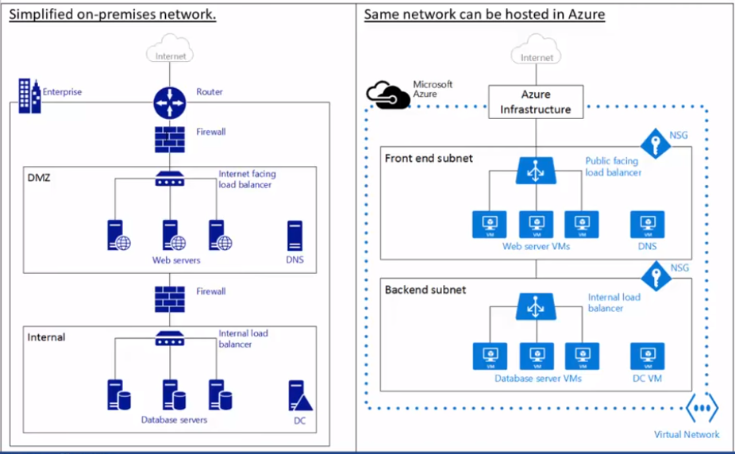

Azure VNet Pricing

* There is no extra cost for using Virtual Networks in Azure
* The compute instances launched within the VNet will be charged the standard rates as described in Azure VM pricing
* The VPN gateway and public IP address used in the VNet will also be charged standard rates

Virtual Network Benefits

* **Isolation.** Vnets are completelyisolated from one another. That allow you to create disjoint network from development, testing, production that use the same CIDR address book
* **Access to the Public internet** All IaaS and PaaS role instances in a Vnet can access the public internet by default. You can control access by using by network security group (NSG)
* **Access to VMs with the Vnet.** PaaS role instanceand IaaS VMs can be launched in the same virtual network and they can connect each other using private IP address if they are in different subnets without need to configure a getaway or use public IP address
* **Name resolution** Azure provide the internal name resolution for IaaS VMs and PaaS role instance deployed in your Vnet you can also deploy your own DNS servers and configure the Vnet use them.
* **Security** traffic entering and existing the virtual machines and PaaS role instance in a Vnet can be controlling use Network Security Group
* **Connectivity** Vnets can be connected to each other, and even to your on-premises datacentre by using Site-to-Site VPN connection or Express route connection.

### Network Security Group:

* Network security group is a layer of security that acts as a virtual firewall for controlling traffic in and out of virtual machines (via network interfaces) and subnets.
* It contains a set of security rules that allow or deny inbound and outbound traffic using the following 5-tuple: protocol, source IP address range, source port range, destination IP address range, and destination port range.
* A network security group can be associated to multiple network interfaces and subnets, but each network interface or subnet can be associated to only one network security group.
* Which inspect the incoming and outgoing traffic on the interface
* Which allows / denies based in the incoming and outgoing rules
* Sit at the network level
* The last rule is denied all
* It can consist of allow rule and deny rule
* Based on priority it will allow or deny the traffic
* Can be associated with multiple virtual machines
* **Name** A unique identifier for the rule
* **Direction** traffic is inbound or outbound
* **Priority** Rule with higher priority apply
* **Access** Specifies whether is traffic is allowed or denied
* **Source IP address Prefix** This identifies from where traffic originates
* **Source Port Range** This specifies port range
* **Destination IP address Prefix** This identifies the destination traffic
* **Destination Port Range** This Specifies destination port range
* **Protocol** protocol specifies a protocol that match the rule it can be UDP, TCP, or the asterisk (**\***)wildcard character

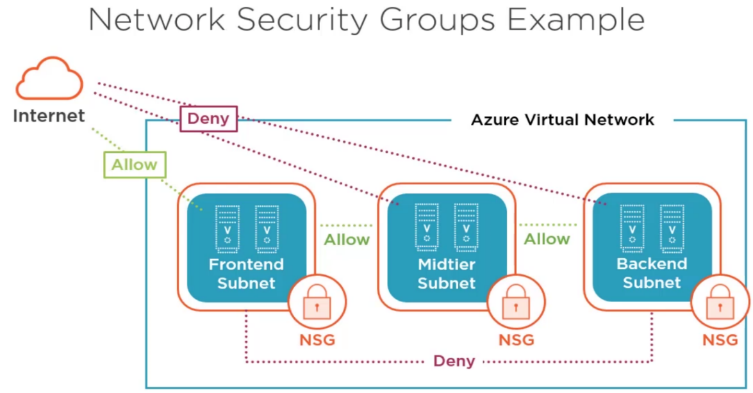

* Traffic flow in a Virtual Network:
* This may not always be desired
* -in a multi- tiered application may want only neighbour tires to communicate
* -May want to restrict types of traffic
* Enable rule to be created then assigned to a network security group
* Applied to subnet or vmNIC
* When applied to subnet it is still enforced at the vmNIC it is not an “edge” device

### Azure Firewall

* Azure Firewall is a managed, cloud-based network security service that protects your Azure Virtual Network resources. It's a fully stateful firewall as a service with built-in high availability and unrestricted cloud scalability.
* NSGs provide the ability to control traffic but is based around IP ranges and implemented in the VFP
* Azure firewall provides a native NVA that is deployed to a virtual network and is highly available and leverages full cloud scalability
* UDR is utilized to direct internet bound traffic via the azure firewall
* Azure firewall enables for FQDN whitelisting and NAT services
* High availability
* Unrestricted scalability
* Azure Firewall is a managed, cloud-based network security service that protects your Azure Virtual Network resources. It's a fully stateful firewall as a service with built-in high availability and unrestricted cloud scalability.

### Application Security Group

* Application Security Groups helps to manage the security of the Azure Virtual Machines by grouping them according the applications that runs on them. It is a feature that allows the application-centric use of Network Security Groups.
* NSGs are focused on the IP address range which may be difficult to maintain for growing environment
* Application Security group (ASGs) enable monikers for different application roles to be defined
* E.g. webserver DD server, web app, webapp2
* The vmNIC for a VM is made a member off one or more ASGs
* The ASGs are used in rule that are part of NSGs to control the flow of communication and can still use NSG features like service tags

### Public Facing IPs

* The private IPs used by VM cannot be used to offer services to the internet
* An internet-routable address public IP, is required
* Azure provides public IP address which can be static or dynamic along with DNS name
* Public IP address are bound to the region they are created in (same region cannot move)
* Customer public IP addresses cannot be used in Azure
* Public IPs are created as an azure resource

Has a DNS name

**<name>. <region>. cloudapp.azure.com**

Assigned to

-A VM (not recommended in most scenarios)

- An azure load balance instance as the front-end address

-A VPN gateway

- An application gateways

A virtual application is a VM in the above

**Stop:** Public IP will be released, and NAT is deleted

Temporary disk will delete permanently

**Start:** Azure will assign Dynamic IP address

NAT attach a temporary storage disk

**Reboot:** Restart the guest O/S

VM will continue to run on the same physical host

VM will have the same public IP

VM will have the same temporary disk

**Delete:** will permanently delete the VM and VM disk public and private IP release temporary Disk

**Dynamic Vs. Static Public IP**

Dynamic IP

* is assigned when a service is started
* Azure will assign when a Vm is started and release when a VM is stopped or deleted.

Use Static IP when

* Azure will assign a public IP, which can exist even vm is powered off
* Static IP is assigned at time of creation
* Will use a DNS name host (A) record pointing to the services
* There are firewall rule or other security based on the service IP address
* SSL certificates that link to the IP address
* Move the static IP

Assigning a public IP to a VM

* When assigning a public IP directly to a VM the OS inside the VM does not see the IP address
* Rather any traffic sent to that public IP address is sent to the VM
* Each IP configuration (on a vmNIC) can have a public IP
* This is a useful option when the service offered needs to use a wide range of ports that would not be possible via port forwarding rules / NAT
  + Passive FTP
* Limits scale and resiliency

### Virtual Applications

Azure network virtual appliance is used in the Azure application to enhance high availability. It is used as an advanced level of control over traffic flows, such as when building a demilitarized zone (DMZ) in the cloud.

A large number of virtual appliances are available in the azure marketplace

License can be based on: -

* Bring your own license
* Hourly billing

Essentially a VM pre-configured software and configuration to perform a certain set of functionalities

Common examples include firewall and load balancer

### Azure Load Balancer

* Azure Load Balancer operates at layer 4 of the OSI model. It's the single point of contact for clients
* Azure Load Balancer can be defined as a cloud-based system that allows a set of machines to perform as one single machine to serve the request of a user.
* With Azure Load Balancer, you can scale your applications and create high availability for your services. Load Balancer supports inbound and outbound scenarios, provides low latency and high throughput, and scales up to millions of flows for all TCP and UDP applications.
* Virtual machines and cloud services in a virtual network can be exposed to using Azure Load balancer.
* Is an explicit object
* With Azure Load Balancer, you can create a load-balancing rule to distribute traffic that arrives at frontend to backend pool instances. Load Balancer uses a hash-based algorithm for distribution of inbound flows and rewrites the headers of flows to backend pool instances accordingly. A server is available to receive new flows when a health probe indicates a healthy backend endpoint
* **Port forwarding**

With Load Balancer, you can create an inbound NAT rule to port forward traffic from a specific port of a specific frontend IP address to a specific port of a specific backend instance inside the virtual network. This is also accomplished by the same hash-based distribution as load balancing

* **Automatic reconfiguration**

Load Balancer instantly reconfigures itself when you scale instances up or down. Adding or removing VMs from the backend pool reconfigures the Load Balancer without additional operations on the Load Balancer resource.

* **Health probes**

To determine the health of instances in the backend pool, Load Balancer uses health probes that you define. When a probe fails to respond, the Load Balancer stops sending new connections to the unhealthy instances. Existing connections are not affected, and they continue until the application terminates the flow, an idle timeout occurs, or the VM is shut down

* **Source IP Affinity mode**

Load Balancer can also be configured by using the source IP affinity distribution mode. This distribution mode is also known as session affinity or client IP affinity. The mode uses a 2-tuple (source IP and destination IP) or 3-tuple (source IP, destination IP, and protocol type) hash to map traffic to the available servers. By using source IP affinity, connections that are initiated from the same client computer go to the same DIP endpoint.

Two types

1. **External Load balancer/ internet-facing load balancer** you can use external load balancer to provide high availability for IaaS VMS and PaaS role instance accessed from the Public internet.

Balances incoming traffic from the internet to VMs in Azure and its front end has a public IP

1. **Internal Load balancer** you can use internal load balancer to provide high availability for IaaS VMs and PaaS role instance accessed from other services in your Vnets.

Balances traffic between VMs in a Virtual network (or connected network) am dots front end has a private IP

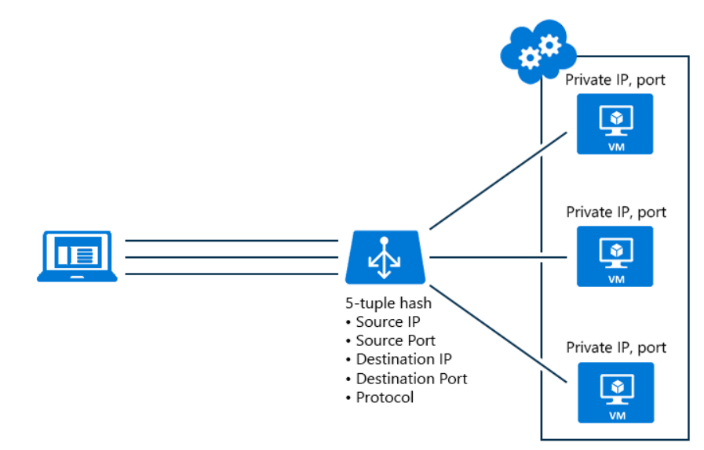

Load balancer can have multiple front-end configuration

Load balancer Services

Hash-based distribution – Actually balancing traffic between multiple targets

Port forwarding – direct incoming traffic to a port on the LB inbound IP and forwarding to a port on specific target (NAT Rules)

Load balancer Stickiness

By defaults uses 5 tuples

-The source IP address

-The destination IP address

-The protocol type (TCP or UDP)

-The source ports

-The destination ports

### Traffic Manger

1. Azure Traffic Manager is a DNS-based traffic load balancer that enables you to distribute traffic optimally to services across global Azure regions,
2. Traffic Manager uses DNS to direct client requests to the most appropriate service endpoint based on a traffic-routing method and the health of the endpoints.
3. An endpoint is any Internet-facing service hosted inside or outside of Azure.
4. Traffic Manager provides a range of [traffic-routing methods](https://docs.microsoft.com/en-us/azure/traffic-manager/traffic-manager-routing-methods) and [endpoint monitoring options](https://docs.microsoft.com/en-us/azure/traffic-manager/traffic-manager-monitoring) to suit different application needs and automatic failover models.
5. Traffic Manager is resilient to failure, including the failure of an entire Azure region.

* Increase application availability
* Improve application performance
* Perform service maintenance without downtime
* Combine hybrid application
* Distribute traffic for complex deployment
* Performance routing to send the requestor to the closest endpoint in terms of latency.
* Priority routing to direct all traffic to an endpoint, with other endpoints as backup.
* Weighted round-robin routing, which distributes traffic based on the weighting that is assigned to each endpoint.
* **Azure endpoints** are used for services hosted in Azure.
* **External endpoints** are used for IPv4/IPv6 addresses, or, for services hosted outside Azure that can either be on-premises or with a different hosting provider.
* **Nested endpoints** are used to combine Traffic Manager profiles to create more flexible traffic-routing schemes to support the needs of larger, more complex deployments.

### Network Security Appliances

Both Microsoft and third-party products

Featuring:

* security and protection
* Infrastructure security
* Web application

Third-party security appliances available through the marketplace

* Barracuda
* Palo alto
* Sophos
* And more

Pricing will vary

* Most have try before you buy
* Scale as needed

Creates a VM

* Sizing options availability will vary

### Availability set

An availability set is a logical grouping of VMs that allows Azure to understand how your application is built to provide redundancy and availability.

It is recommended that two or more VMs are created within an availability set to provide for a highly available application and to meet the 99.95% Azure SLA.

When a single VM is used with Azure Premium Storage, the Azure SLA applies for unplanned maintenance events.

Consist of Fault domain and update domain

Consist of VM which are running the same application

Distribute the VMs which are in availability set to different fault domains and updates domains

**Fault domain:** Set of physical servers connected to same power source and network source

**Update domain:** set of physical servers running win2012 Hyper-V where MS will do patch management or firmware upgradations at once

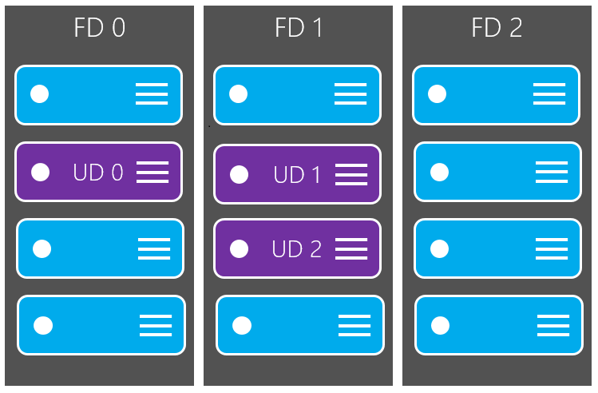

### Availability Zone

Availability Zone is an isolated location inside of an Azure Region, and has its own independent power source, network, and cooling. The physical and logical separation of Availability Zones within an Azure region protects applications and data from zone-level failures. Availability Zone data transfer pricing is based on Availability Zones.

### Auto scaling

Auto scaling is the process of dynamically allocating resources to match performance requirements.

As the volume of work grows, an application may need additional resources to maintain the desired performance levels and satisfy service-level agreements (SLAs). As demand slackens and the additional resources are no longer needed, they can be de-allocated to minimize costs.

**Limitations**

SKUs are not mutable. You may not change the SKU of an existing resource.

A Load Balancer rule cannot span two virtual networks. Frontends and their related backend instances must be located in the same virtual network.

Load Balancer frontends are not accessible across global virtual network peering

**a) Vertical scaling,** also called scaling up and down, means changing the capacity of a resource. For example, you could move an application to a larger VM size. Vertical scaling often requires making the system temporarily unavailable while it is being redeployed. Therefore, it's less common to automate vertical scaling.

**b) Horizontal scaling,** also called scaling out and in, means adding or removing instances of a resource. The application continues running without interruption as new resources are provisioned. When the provisioning process is complete, the solution is deployed on these additional resources. If demand drops, the additional resources can be shut down cleanly and deallocated.

### Azure Application Gateway

* Azure Application Gateway is a web traffic load balancer that enables you to manage traffic to your web applications.
* Traditional load balancers operate at the transport layer (OSI layer 7 - TCP and UDP) and route traffic based on source IP address and port, to a destination IP address and port.
* Application Gateway you can be even more specific. For example, you can route traffic based on the incoming URL. So, if /images is in the incoming URL, you can route traffic to a specific set of servers (known as a pool) configured for images. If /video is in the URL, that traffic is routed to another pool optimized for videos.
* Can routes the traffic based on the URL
* Features
* Autoscaling
* SSL termination
* Connection draining
* Web application firewall
* URL-based routing
* ETC.

**Static VIP** - The application gateway VIP now supports the static VIP type exclusively. This ensures that the VIP associated with application gateway does not change even after a restart.

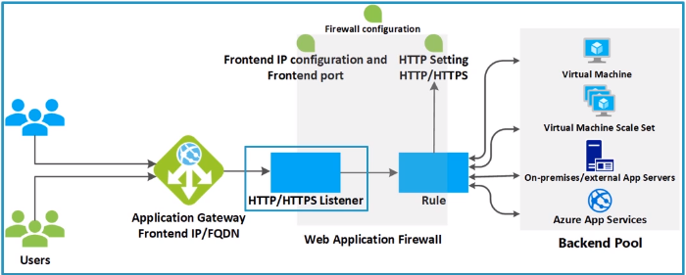

PaaS and azure SQL database Vnet integration

### PaaS and Azure SQL database

A solution may use a combination of Azure services

Azure App services can integrate with a Vnet using point- to -site VPN

An Azure App services environment can be created default in a Vnet as can various other PaaS services

Azure SQL data has its own firewall and through service endpoints can be locked down to specific subnet or use a NVZ

Service Endpoints

Many Azure Services are public facing

Customer may wish to lock down access to specific azure VMs

Previously some services enabled a lock down to azure services but this would include any Azure tenant or by using a set public IP from IaaS Services

Service endpoints enable subnets within a virtual network to be identifiable to the access security of the service thereby locking down access specific subnets

Traffic stays on the Azure backbone.

### Azure DDOs standard protection

* A malicious attempt to disrupt normal traffic by flooding a website with large amount of fake traffic.
* Distributed denial of service (DDos) is a major threat to internet facing services
* Azure provides a basic large-scale DDos protection for all services but its tolerance is not configurable nor can it be monitored.
* Azure DDos standard protection is enabled at a virtual network level based on user-defined policies that is applied to all public IPs associated with resource in the virtual network.
* Real-time monitoring and telemetry available
* Services basic and standard
* Instant on protection
* Traffic monitoring
* Adaptive tuning
* Attack analytics, metrics, and alerting

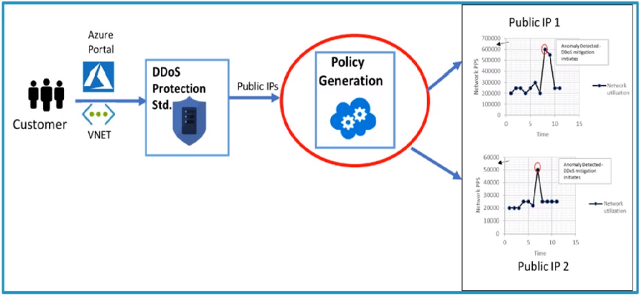

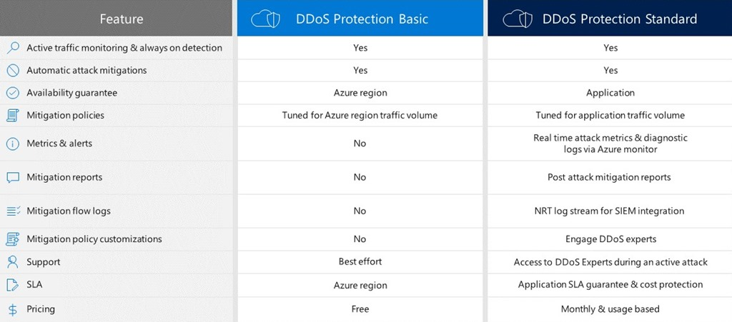

### Network Peering

* Enable connectivity between virtual networks using the Azure backbone without gateway
* Nominal ingress and egress cost
* Can be different regions (global Vnet Peering) and different subscriptions
* Utilize S2S VPN between virtual networks
* Connect virtual networks to the same ExpressRoute circuit (or circuits that have routing between them)
* Utilize NVA
* VNet peering - connecting VNets within the same Azure region
* Global VNet peering - connecting VNets across Azure regions

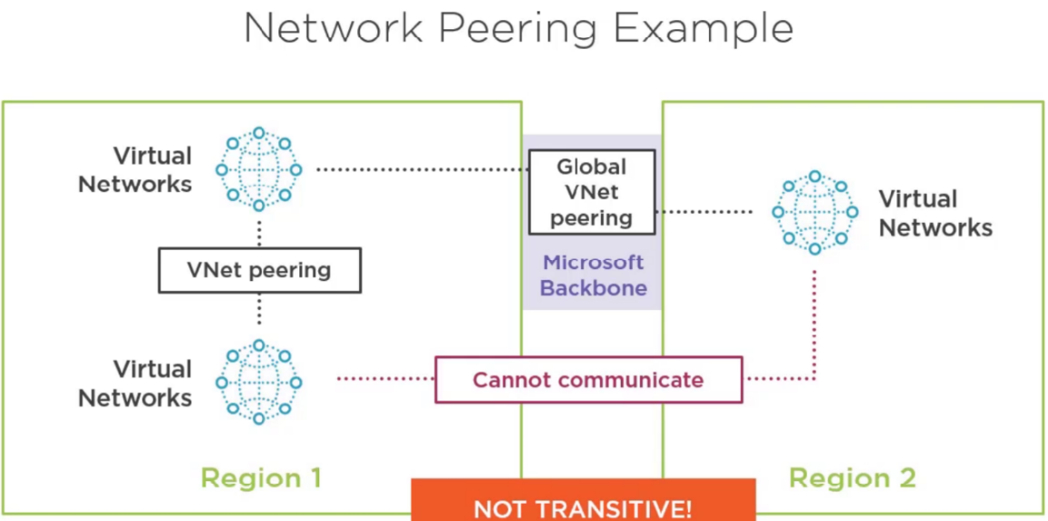

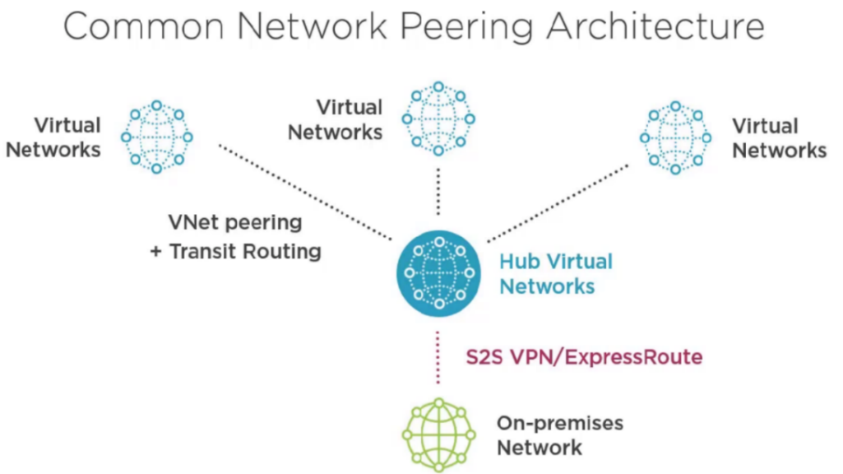

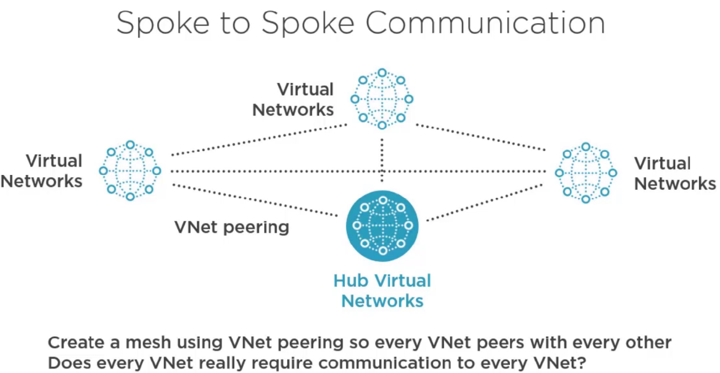

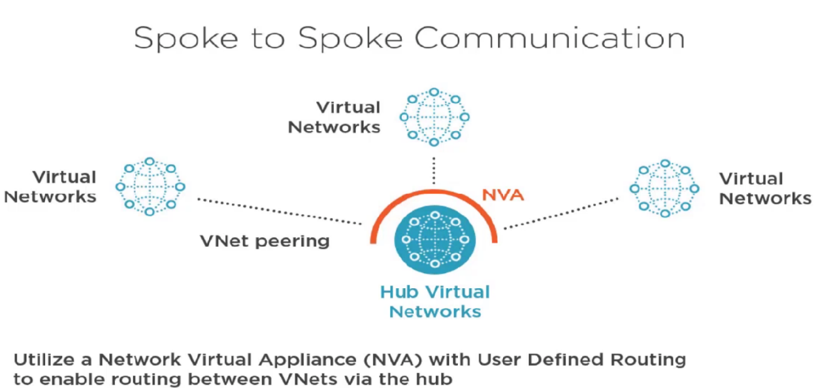

Routing between Azure and on-premises

* Must use unique IP address ranges
* It is not possible to route between networks that use the same IP scheme
* Includes on-premises to Azure
* Azure Vnet to Azure Vnet
* VMs cannot be moved between virtual networks without deleting and recreating
* Get the virtual networks right first time

Types of peering

* Site to site VPN is private peering connecting to a virtual network which is available with ExpressRoute
* ExpressRoute also supports Microsoft peering
* Microsoft peering provides access to nearly all Azure, office and Dynamics services via ExpressRoute instead internet. Premium required for office/Dynamics

### Azure VPN Gateway

Used to send encrypted traffic between an azure virtual network and on-prem location over the internet

Can also be used between azure virtual networks

* Encrypted traffic across the azure platform

Connects with azure validated devices

Types of VPN Gateway

* IPSEC is computationally expensive which limits bandwidth

Four SKUs of gateway

* Basic -100 Mbps - VpnGw1 – 500 Mbps
* VpnGw2 -1 Gbps - VpnGw3 – 1.25 Gbps
* Latency will depend on many factors but expect inconsistency
* Basic support 10 tunnels while others support 30
* There are also old SKUs of standard and high performance
* Traffic outside the region/ datacenter would result in egress traffic charges
* Use network peering if possible instead

### Point-to -Site VPN

* Allows connection from individual computer to VMs on Azure
* Computers can be on any network that connects to the internet
* SSTP VPN (secure socket tunneling protocol)
* Uses certificate authentication
* Upload root certificate to Azure
* Install client certificate on computers that will use point -to -site VPN client

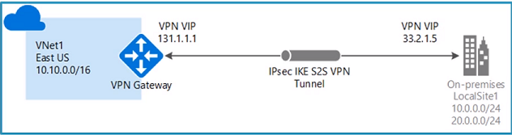

### Site -to -Site VPN

* Used for connecting on-premises network to Azure networks
* Provides connectivity between a virtual network and an on-premises network or another virtual network
* To on-premises connects over the internet
* Virtual networks can be in different regions and different subscription
* Uses IPsec/IKE to encrypt the traffic.
* Allow bi-directional communication between Azure and connected site
* Allows extension of on-premises network into Azure without making resources accessible to host on the internet
* Requires compatible of on-premises routing device
* Templets available for commonly used routers / internet gateways
* Ensure that Azure address space does not overlap on-premises address space
* IPsec VPN
* Azure side VPN gateway requires its own subnet
* Common when creating subnet in new virtual network is to leave an address space at the start to use for the gateway
* Don not use NSG with the gateway subnet

Azure Virtual WAN

* For origination with large number of branches locations providing connectivity between them can be complex
* Azure virtual WAN provides an Azure-based hub services that eases the setup and connectivity
* Remote offices connect via active-active tunnels over an IPsec encrypted VPN connection
* Connectivity is provided between locations and Azure connected virtual networks

Site – to- Site VPN challenges

* It uses the internet
* Bandwidth
* Unpredictable latency
* Security may not meet requirements
* Potentially greater networking cost

### ExpressRoute

ExpressRoute is an Azure service that lets you create private connections between Microsoft datacenters and infrastructure that's on your premises or in a colocation facility. ExpressRoute connections do not go over the public Internet, and offer higher security, reliability, and speeds with lower latencies than typical connections over the Internet.Up to 10GB/sec

* Redundant connection
* Predictable performance
* Hight throughput
* SLA
* Traffic does not flow across public internet
* Requires that ExpressRoute available locally
* Exchange provider facility
* Direct connection using network services provider (point -to-point ethernet)
* Any-to-Any (IPVPN) connection (Network service provider)
* Provides layer 3 connectivity from your location to Azure over the private connection
* Does NOT use the internet so does not need to encrypt
* Uses BGP for routing enabling forced tunneling
* Care should be structured as if all traffic is forced through customer location; that would include access to other Azure services like storage
* Rules should be structured so that Azure services (Microsoft peering) still route via Azure backbone and not via on-premises location unless this is specifically desired
* No encryption required with ExpressRoute
* For SKU of gateway

Basic -500 Mbps (deprecated)

Standard -1000 Mbps

High Performance 2000 Mbps

Ultra-performance – 9000 Mbps

* **Unlimited data.** Billing is based on a monthly fee; all inbound and outbound data transfer is included free of charge.
* **Metered data.** Billing is based on a monthly fee; all inbound data transfer is free of charge. Outbound data transfer is charged per GB of data transfer. Data transfer rates vary by region.
* **ExpressRoute premium add-on**. ExpressRoute premium is an add-on to the ExpressRoute circuit. The ExpressRoute premium add-on provides the following capabilities:
* Increased route limits for Azure public and Azure private peering from 4,000 routes to 10,000 routes.
* Global connectivity for services. An ExpressRoute circuit created in any region (excluding national clouds) will have access to resources across any other region in the world. For example, a virtual network created in West Europe can be accessed through an ExpressRoute circuit provisioned in Silicon Valley.
* Increased number of VNet links per ExpressRoute circuit from 10 to a larger limit, depending on the bandwidth of the circuit.

Route Filters

* Origination may not want all services advertised via ExpressRoute
* Route filters enable control of certain services based on BGP community value, e.g. Exchange
* Azure services by region can also be controlled via route filters

Connecting Azure Vnets with ExpressRoute

* Multiple virtual networks are automatically connected by connecting them to the same ExpressRoute
* Standard ExpressRoute supports connecting any in the same geo-political boundary e.g any US region
* ExpressRoute premium support connecting any globally
* Communications are via the peering point so that should be considered carefully as it may increase latency compared to other options, i.e. network peering

### Azure Private Link

Azure Private Link enables you to access Azure PaaS Services (for example, Azure Storage and SQL Database) and Azure hosted customer-owned/partner services over a private endpoint in your virtual network.

Traffic between your virtual network and the service travels the Microsoft backbone network. Exposing your service to the public internet is no longer necessary. You can create your own private link service in your virtual network and deliver it to your customers. Setup and consumption using Azure Private Link is consistent across Azure PaaS, customer-owned, and shared partner services.

Key benefits

Azure Private Link provides the following benefits:

Privately access services on the Azure platform: Connect your virtual network to services in Azure without a public IP address at the source or destination. Service providers can render their services in their own virtual network and consumers can access those services in their local virtual network. The Private Link platform will handle the connectivity between the consumer and services over the Azure backbone network.

On-premises and peered networks: Access services running in Azure from on-premises over ExpressRoute private peering, VPN tunnels, and peered virtual networks using private endpoints. There's no need to set up public peering or traverse the internet to reach the service. Private Link provides a secure way to migrate workloads to Azure.

Protection against data leakage: A private endpoint is mapped to an instance of a PaaS resource instead of the entire service. Consumers can only connect to the specific resource. Access to any other resource in the service is blocked. This mechanism provides protection against data leakage risks.

Global reach: Connect privately to services running in other regions. The consumer's virtual network could be in region A and it can connect to services behind Private Link in region B.

Extend to your own services: Enable the same experience and functionality to render your service privately to consumers in Azure. By placing your service behind a standard Azure Load Balancer, you can enable it for Private Link. The consumer can then connect directly to your service using a private endpoint in their own virtual network. You can manage the connection requests using an approval call flow. Azure Private Link works for consumers and services belonging to different Azure Active Directory tenants.

### Network Monitoring Requirements

* In Azure the network fabric is the responsible of Microsoft, so no monitoring of physical infrastructure is required.
* Even with Azure IaaS VMs there is no access to the underlying network fabric
* This means no fabric level monitoring tools can be used
* Any agent can run with in the VM to examine local traffic and pass details to a target
* No network monitoring in promiscuous mode will work

### Azure Monitor

* A single source for the monitoring of Azure resource
* Provide insight into log metric alerts
* Can create action groups which can be utilized as part of alerts to perform multiple actions centrally defined

### Azure Network Watcher

* An instance is deployed to a region for services in that region
* Large number of capabilities
* Topology viewer
* Packet capture (Via an agent installed into VM)
* IP flow verify and next hop determination
* Connection monitor and troubleshoot
* Security group viewer
* NSG flow logging
* Virtual network gateway and virtual network connection troubleshooting
* Network use against subscription limits
* Enable or disable log for resource for virtual network

### Hub-spoke network topology

This reference architecture shows how to implement a hub-spoke topology in Azure. The hub is a virtual network in Azure that acts as a central point of connectivity to your on-premises network. The spokes are virtual networks that peer with the hub, and can be used to isolate workloads. Traffic flows between the on-premises datacenter and the hub through an ExpressRoute or VPN gateway connection

The benefits of this topology include:

Cost savings by centralizing services that can be shared by multiple workloads, such as network virtual appliances (NVAs) and DNS servers, in a single location.

Overcome subscriptions limits by peering virtual networks from different subscriptions to the central hub.

Separation of concerns between central IT (SecOps, InfraOps) and workloads (DevOps).

Typical uses for this architecture include:

Workloads deployed in different environments, such as development, testing, and production, that require shared services such as DNS, IDS, NTP, or AD DS. Shared services are placed in the hub virtual network, while each environment is deployed to a spoke to maintain isolation.

Workloads that do not require connectivity to each other, but require access to shared services.

Enterprises that require central control over security aspects, such as a firewall in the hub as a DMZ, and segregated management for the workloads in each spoke.

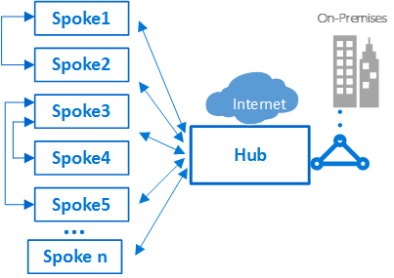

# **Azure Storage**

Azure storage provides storage that is highly available, secure, durable, scalable and redundant.

**Azure Storage options:**

* **General purpose V2 (GPv2)**
* Accounts provide all the latest features, and supports blobs, files, Queues, and tables
* This include blob- level tiering, archive storage, higher scale account limits, and storage events.
* For block blobs, you can choose between hot and cool storage tires at the account level, or hot, cool, and archive tires at the blob level based on access patterns.
* Storage frequently, infrequently and rarely accessed data in the hot, cool, and archive storage tiers respectively to optimize cost.
* Importantly, and GPv1 account can be upgrade to GPv2 account in the portal, CLI or PowerShell.
* **General purpose V1 (GPv1)**

Account provide use of all azure storage services but may not have the latest features or the lowest GB pricing.

For example, cool and archive storage are not supported in GPv1

* **Blob Storage**

Account provide all the latest features for block blobs, but only support block blobs

**Azure Storage: pricing**

All storage accounts use a pricing model for blob storage based on the tire or each blob

* When using a storage account, that following billing consideration apply:
* **Storage Costs**
* The cost of storing data varies depending on the storage tier
* The per-gigabyte cost decreases as the tire gets cooler
* **Data access costs**
* Data access charges increase as the tire gets cooler
* For data in the cool and archive storage tier, you are charged a per-gigabyte data access charged for reads.
* **Transaction cost**
* There is a per-transaction charge for all tires
* **Geo-replication data transfer costs**
* This only applies to accounts with geo-replication configured, including GRS and RA-GRS.
* GEO-replication data transfer incurs a per gigabyte charge

**Azure Storage: Security**

* Azure storage provides a comprehensive set of security capabilities.
* The storage account itself can be secured using role-based access control and azure active directory
* Data can be secured in transit between an application and azure by using client-side encryption, HTTPS, or SMB 3.0
* Data can be set to be automatically encrypted when written to azure storage using storage service encryption. SSE is at storage level
* OS and data disk used by virtual machine can be set to be encrypted using Azure disk encryption. ADE is more like OS level encryption
* Delegate access to the data objects in azure storage can be granted using shared access signature

## Azure Disks

A data disk is a VHD that's attached to a virtual machine to store application data, or other data you need to keep. Data disks are registered as SCSI drives and are labeled with a letter that you choose. Each data disk has a maximum capacity of 4,095 GB, managed disks have a maximum capacity of 32,767 GiB. The size of the virtual machine determines how many data disks you can attach to it and the type of storage you can use to host the disks.

Azure creates an operating system disk when you create a virtual machine from an image. If you use an image that includes data disks, Azure also creates the data disks when it creates the virtual machine. Otherwise, you add data disks after you create the virtual machine.

You can add data disks to a virtual machine at any time, by **attaching** the disk to the virtual machine. You can use a VHD that you've uploaded or copied to your storage account or use an empty VHD that Azure creates for you. Attaching a data disk associates the VHD file with the VM by placing a 'lease' on the VHD so it can't be deleted from storage while it's still attached.

Unmanaged Disks

Unmanaged disks are the traditional type of disks that have been used by VMs. With these disks, you create your own storage account and specify that storage account when you create the disk. Make sure you don't put too many disks in the same storage account, because you could exceed the [scalability targets](https://docs.microsoft.com/en-us/azure/storage/common/storage-scalability-targets) of the storage account (20,000 IOPS, for example), resulting in the VMs being throttled. With unmanaged disks, you must figure out how to maximize the use of one or more storage accounts to get the best performance out of your VMs.

Managed Disks

Managed Disks handles the storage account creation/management in the background for you and ensures that you do not have to worry about the scalability limits of the storage account. You simply specify the disk size and the performance tier (Standard/Premium), and Azure creates and manages the disk for you. As you add disks or scale the VM up and down, you don't have to worry about the storage being used.

|  |  |
| --- | --- |
| **Managed Disks** | **Unmanaged Disks** |
| * Up to 1000 storage accounts per region | * Up to 200 storage accounts per region |
| * Storage accounts performance limits not relevant. | * Up to 40 disks per standard storage accounts. |
| * Disks of VMs in the same availability set in the different stamps | * Storage accounts per VMs in the same availability set might be in the same storage stamp |
| * A custom image must be in the same region as VM disks | * A custom image must be in the same storage account as VM disk |
| * Simple and scalable VM deployment |  |
| * Better reliability for Availability Sets |  |
| * Highly durable and available * Granular access control * Azure Backup service support |  |

Standard HDD disks

Standard HDD disks are backed by HDDs and deliver cost-effective storage. Standard HDD storage can be replicated locally in one datacenter or be geo-redundant with primary and secondary data centers. For more information about storage replication, see Azure Storage replication.

Standard SSD disks

Standard SSD disks are designed to address the same kind of workloads as Standard HDD disks, but offer more consistent performance and reliability than HDD. Standard SSD disks combine elements of Premium SSD disks and Standard HDD disks to form a cost-effective solution best suited for applications like web servers that do not need high IOPS on disks. Where available, Standard SSD disks are the recommended deployment option for most workloads. Standard SSD disks are available as Managed Disks in all regions but are currently only available with the locally redundant storage (LRS) resiliency type

Premium SSD disks

Azure Premium Storage delivers high-performance, low-latency disk support for virtual machines (VMs) with input/output (I/O)-intensive workloads. VM disks that use Premium Storage store data on solid-state drives (SSDs). To take advantage of the speed and performance of premium storage disks, you can migrate existing VM disks to Premium Storage.

**Azure Storage: Tiers**

* **Premium storage (preview)** provides high performance hardware for data that is accessed frequently.
* **Hot storage**: is optimized for storing data that is accessed frequently.
* **Cool storage** is optimized for storing data that is infrequently accessed and stored for at least 30 days.
* **Archive storage** is optimized for storing data that is rarely accessed and stored for at least 180 days with flexible latency requirements (on the order of hours).

|  |  |  |  |
| --- | --- | --- | --- |
| **Disk Type** | **Premium SSD** | **new Standard SSD** | **Standard HDD** |
|  |  |  |  |
| Summary | Designed for IO intensive enterprise workloads. Delivers consistent performance with low latency and high availability. | Designed to provide consistent performance for low IOPS workloads. Delivers better availability and latency compared to HDD Disks. | Optimized for low-cost mass storage with infrequent access. Can exhibit some variability in performance. |
| Workload | Demanding enterprise workloads such as SQL Server, Oracle, Dynamics, Exchange Server, MySQL, Cassandra, MongoDB, SAP Business Suite, and other production workloads | Web servers, low IOPS application servers, lightly used enterprise applications, and Dev/Test | Backup storage |
| Max IOPS | 7,500 IOPS provisioned | Up to 500 IOPS | Up to 500 IOPS |
| Max Throughput | 250 MBPS provisioned | Up to 60 MBPS | Up to 60 MBPS |

## Storage Account

Azure storage or azure account is a service from Azure, which provides storage service for various use case. Azure storage is the cloud solution for modern application that rely on durability, availability and scalability to meet the needs of their customers.

* An azure storage account provides a unique namespace to store and access your Azure storage data object
* In order to use Azure Storage, you begin by creating a storage account.
* You can create many storage accounts within a single Azure subscription.
* Each storage account can contain up to 500 TB of data.
* For each storage account, you must specify:

URL

Location or Affinity Group

Replication

http(s)://account_name.file.core.windows.net

Storage Replication

Locally – Redundant storage (LRS)

Zone – Redundant storage (ZRS)

Geo – Redundant storage (GRS)

Read Access Geo – Redundant storage (RA-GRS)

## Blob: (Binary Large Objects)

<File Name>.blob.core.windows.net

* Azure Blob Storage is a service for storing large amount of unstructured object data, such as text or binary data.
* Blob storage can any type of text or binary data, such as a document, media files or application installer.
* You can use blob storage to expose data publicly to the world, or to store application data privately.
* Blob storage is also referred to as object storage.
* You can create any number of containers within a single storage account.
* Within each container, you can store any number of blobs up to the 500 TB limit.

File, document, image, video, VM disk, database, etc.

**Storage Account**

* All access to Azure Storage is done through a storage account.
* This account can be a general-purpose or a blob storage.

**Container**

* A container provides a grouping of a set of blobs
* All blobs must be in a container
* An account can contain an unlimited number of containers
* A container can store an unlimited number of blobs

**Tiers**

* **Hot storage**: is optimized for storing data that is accessed frequently. Higher Storage cost, Lower Transition cost
* **Cool storage** is optimized for storing data that is infrequently accessed and stored for at least 30 days. Lower transition cost, higher transition cost
* **Archive storage** is optimized for storing data that is rarely accessed and stored for at least 180 days with flexible latency requirements (on the order of hours). Lower transition cost, higher transition cost

**Blob**

* A file of any type and size.
* Azure storage offers three types of blobs

**Block Blob**

* Used for storing text or binary files, such as documents and media files.
* Each block can be a different size, up to a maximum of 100 MB.
* A single block blob can contain up to 50,000 blocks. Individual blocks bobs can be up to 4.75 TB in size (100MBx 50,000)
* With a block blob, you can upload multiple blocks in parallel to decrease upload time.

**Append Blob**

* Each block in an append blob can be a different size, up to a maximum of 4 MB
* are made up of blocks like block blobs, but are optimized for append operations. Append blobs are ideal for scenarios such as logging data from virtual machines.
* A single append blob can contain up to 50,000 blocks for a total size of slightly more than 195GB (4MB x 50,000)

**Page Blob**

* store random access files up to 8 TB in size. Page blobs store virtual hard drive (VHD) files and serve as disks for Azure virtual machines.
* Page blob are a collection of 512-byte pages optimized for random read and write operations
* Can be up to 8 TB in size, and are more efficient for frequent read/write operations

You can interact with Blob Storage through any of the below

AzCopy – a command-line interface to be downloaded locally

Azure Data Factory

Azure SDKs (.NET, Java, Python etc.) – allowing you to interact with Azure Storage directly within Python or R

Azure Data Box Disk

Azure Import/Export service

## Queue

* Azure Queue Storage is service for storing large number of **Messages** that can be accessed from anywhere in the world via authenticated call using HTTP or HTTPS.
* The azure queues storage service provides temporary messaging store.
* A single queue message can be up to 64KB in size, and queue can contain millions of messages, up to total capacity limits of a storage account.
* Queue Storage enables messages queueing for large workloads in simple, cost-effective and durable manner

**What are the advantages of Azure Queue storage?**

* Enables users to build flexible apps and separate functions for greater durability
* It provides rich client libraries for java, Android, C++, PHP, Ruby, Etc.
* Ensures users’ applications are scalable and less prone to individual component failure.
* Enables queue monitoring to ensure servers aren’t overwhelmed by sudden traffic

https://<storage.account>.queue.core.windows.net/queue

## File System

* Azure files offer fully managed file shares in the cloud that are accessible via common internet file system (CIFS)
* Azure file shares can be mounted concurrently by cloud or on-premises deployment of windows, linux, and macOS
* up to the 5TB total capacity of the file share.
* A file storage share is an SMB file share in Azure.
* All directories and files must be created in a parent share.
* Azure storage account can store multiple shares with a total of 500 TiB stored across all shares.
* **Azure files support two data redundancy options:**

LRS

GRS

* **Replace or supplement on-premises file servers**
* Azure file can be used to completely replace or supplement traditional on-premises file servers or NAS
* **“Lift” and “Shift” applications**
* Azure files make it easy to “lift and shift” application to the cloud that expect a file share to store files applications or user data.

**Azure files data access method**

Azure files offer two data access methods that you can use separately, or in combination with each other to access your data:

**Direct cloud Access:**

Azure file share can be mounted by windows, macOS and/or linux.

**Azure file Sync:**

With azure file sync, shares can be replicated to windows server on-premises or in azure.

Users would access the file share through the windows server

Data may be replicated between multiple windows server endpoints.

Data tired to azure files, but the server does not have a full copy of the data

Rather, data is seamlessly recalled when opened by your user.

<File Name>.file.core.windows.net

## Tables

* The Azure table storage service to store large amount of structure data stores partially.
* With each storage account, you can create multiple tables, and each table can contain multiple entities.
* The Service is a No SQL data store which accepts authenticated calls from inside and outside the Azure cloud,
* Azure tables are ideal for storing structured, non-relations data.
* Developers can use table storage as the back-end data store for websites, mobile apps, PaaS cloud services, and other types of solution

<File Name>.table.core.windows.net

Azure

Data transfer

Azure Data Box family for offline transfers

Azure Data Box family for offline transfers – Use devices from Microsoft-supplied Data Box devices to move large amounts of data to Azure when you’re limited by time, network availability, or costs. Copy on-premises data using tools such as Robocopy. Depending on the data size intended for transfer, you can choose from Data Box Disk, Data Box, or Data Box Heavy.

Azure Import/Export –

Use Azure Import/Export service by shipping your own disk drives to securely import large amounts of data to Azure Blob storage and Azure Files.

This service can also be used to transfer data from Azure Blob storage to disk drives and ship to your on-premises sites.

High network bandwidth (1 Gbps - 100 Gbps)

If the available network bandwidth is high, use one of the following tools.

AzCopy - Use this command-line tool to easily copy data to and from Azure Blobs, Files, and Table storage with optimal performance. AzCopy supports concurrency and parallelism, and the ability to resume copy operations when interrupted.

Azure Storage REST APIs/SDKs – When building an application, you can develop the application against Azure Storage REST APIs and use the Azure SDKs offered in multiple languages.

Azure Data Box family for online transfers – Data Box Edge and Data Box Gateway are online network devices that can move data into and out of Azure. Use Data Box Edge physical device when there is a simultaneous need for continuous ingestion and pre-processing of the data prior to upload. Data Box Gateway is a virtual version of the device with the same data transfer capabilities. In each case, the data transfer is managed by the device.

Azure Data Factory – Data Factory should be used to scale out a transfer operation, and if there is a need for orchestration and enterprise grade monitoring capabilities. Use Data Factory to regularly transfer files between several Azure services, on-premises, or a combination of the two. with Data Factory, you can create and schedule data-driven workflows (called pipelines) that ingest data from disparate data stores and automate data movement and data transformation.

Azure Data Box family for online transfers - Data Box Edge and Data Box Gateway are online network devices that can move data into and out of Azure. Data Box Edge uses artificial intelligence (AI)-enabled Edge compute to pre-process data before upload. Data Box Gateway is a virtual version of the device with the same data transfer capabilities.

Scripting/programmatic tools such as AzCopy/PowerShell/Azure CLI and Azure Storage REST APIs.

AzCopy - Use this command-line tool to easily copy data to and from Azure Blobs, Files, and Table storage with optimal performance. AzCopy supports concurrency and parallelism, and the ability to resume copy operations when interrupted.

Azure PowerShell - For users comfortable with system administration, use the Azure Storage module in Azure PowerShell to transfer data.

Azure CLI - Use this cross-platform tool to manage Azure services and upload data to Azure Storage.

Azure Storage REST APIs/SDKs – When building an application, you can develop the application against Azure Storage REST APIs/SDKs and use the Azure client libraries offered in multiple languages.

## Azure File Sync

Use Azure File Sync to centralize your organization's file shares in Azure Files, while keeping the flexibility, performance, and compatibility of an on-premises file server. Azure File Sync transforms Windows Server into a quick cache of your Azure file share. You can use any protocol that's available on Windows Server to access your data locally, including SMB, NFS, and FTPS. You can have as many caches as you need across the world.

**Direct mount of an Azure file share:** Since Azure Files provides SMB access, you can mount Azure file shares on-premises or in the cloud using the standard SMB client available in Windows, macOS, and Linux. Because Azure file shares are serverless, deploying for production scenarios does not require managing a file server or NAS device. This means you don't have to apply software patches or swap out physical disks.

**Cache Azure file share on-premises with Azure File Sync:** Azure File Sync enables you to centralize your organization's file shares in Azure Files, while keeping the flexibility, performance, and compatibility of an on-premises file server. Azure File Sync transforms an on-premises (or cloud) Windows Server into a quick cache of your Azure file share.

# **Azure Data Factory**

* Modern data handling requires you to move from on premise DB to cloud DW
* This Data needs processing and goes through a series of steps, making the process tedious
* Data Factory: helps you automate this process and thus serve the cause

It is a **cloud-based data integration service** that allows to create data-driven workflows in the cloud for orchestrating and automating data movement and transformation.

Using azure data factory, you can create and schedule data-driven workflow (called pipeline) that can ingest data from disparate data stores.

It can process and transform the data by using compute service such as azure HDinsight Hadoop, spark, Azure data lake Analytics, and Azure machine learning.



**Data factory concepts**

**Pipeline:** A pipeline is a logical grouping of activities that performs a unity of work

**Activity:**  Activities represent processing step in a pipeline

Is step or task such as copying data in pipeline. Three types

* Data Movement activities
* Data Transformation activities
* Control activities

**Dataset:** datasets represent data structure within the data stores

**Linked Services:** information needed to connect to external sources

**Gateway:** connects your on-premises data to cloud

**Data Lake:** it is an enterprise wide hyperscale repository for big data analytics workload. Azure data lake holds data of any size, type and allows you to do operational and exploratory analytics.

**Key:**

Analytics on data of any size

All users productive on day one

Ready for your enterprise

**Types of Data Stored:**

Structured data

Semi structured data

Unstructured data

# Microsoft Azure Site Recovery

[Microsoft link](https://docs.microsoft.com/en-us/azure/site-recovery/vmware-physical-azure-support-matrix#replicated-machines)

As an organization you need to adopt a business continuity and disaster recovery (BCDR) strategy that keeps your data safe, and your apps and workloads up and running, when planned and unplanned outages occur.

* **Site Recovery service**: Site Recovery helps ensure business continuity by keeping business apps and workloads running during outages. Site Recovery replicates workloads running on physical and virtual machines (VMs) from a primary site to a secondary location. When an outage occurs at your primary site, you fail over to secondary location, and access apps from there. After the primary location is running again, you can fail back to it.
* **Backup service**: The [Azure Backup](https://docs.microsoft.com/azure/backup/) service keeps your data safe and recoverable by backing it up to Azure

How site recovery work

Replicating Azure, VMware, Hyper-V, VM’s and physical servers

Leveraging existing HA/DR options

Working with the ASR deployment planner

BC/DR

Continue replication

APP-consistent snapshot

Flexible failovers

Recovery plans

Azure Automation integration

Creating recovery vault

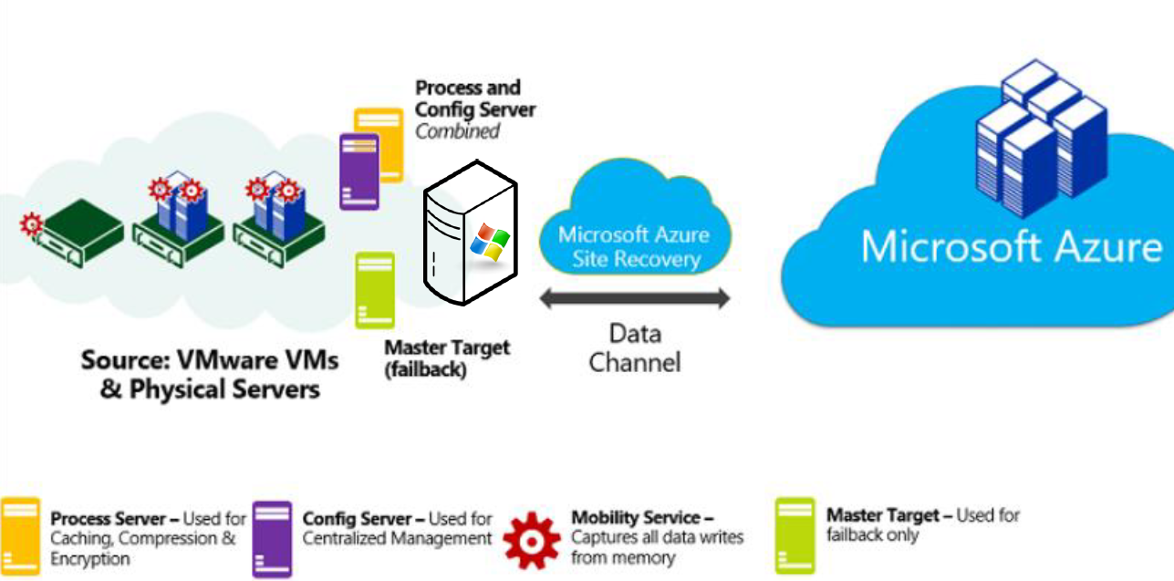

Extension Mobility Service

* It is going to read the data from RAM, when there is a write to ram it will send the data from physical machine/ VMWare server to process server
* Coordinates replication between on-premises VMware servers/physical servers and Azure/secondary site  
  Installed on VMware VM or physical servers you want to replicate

Process server component

* Used for caching, compressing, and encryption.
* Used for caching, compression & encryption followed by pushing the data into storage
* Installed by default on the configuration server. It receives replication data; optimizes it with caching, compression, and encryption; and sends it to Azure Storage. As your deployment grows, you can add additional, separate process servers to handle larger volumes of replication traffic

Configuration server component

* Used for centralized management, Master target server component
* This will have the configuration of all the physical server. Used for centralized management. Install the mobility service on target systems
* Coordinates communications between on-premises VMware servers and Azure

Master Target Server – Used for fail back to on premise infra

<https://docs.microsoft.com/en-us/azure/site-recovery/site-recovery-plan-capacity-vmware>

QUESTIONS AND ANSWERS

<https://docs.microsoft.com/en-us/azure/site-recovery/vmware-azure-common-questions>

<https://docs.microsoft.com/en-us/azure/site-recovery/vmware-azure-deploy-configuration-server#prerequisites>

# Azure AD

Azure Active Directory is an Identity and Access Management system. It is used to grant access to your employees to specific products and services in your network. For example: Salesforce.com, twitter etc. Azure AD has some in-built support for applications in its gallery which can be added directly.

## MFA (Multi-Factor Authentication) on Azure

Provides additional security by requiring a second from of authentication

Many options can be configured by the admin to better customize the user experience

The organization can determine the preferred authentication methods

Fraud alerts can be configured

The multi-Factor authentication can be configured to accept different forms of authentication methods

Calling your phone

Sending a text massage

Notification in authenticator app

Verification code

## Microsoft Intune

Microsoft Intune is a cloud-based enterprise mobility management tool that aims to help organizations manage the mobile devices employees use to access corporate data and applications, such as email.

It is a component of Microsoft's Enterprise Mobility + Security (EMS) offering, a mobile device management and application management platform. Microsoft's Intune app is designed to integrate with other parts of the EMS platform, including Azure Active Directory and Azure Information Protection. The app protection policy component of Microsoft Intune uses Azure Active Directory identity to maintain separation between corporate and personal data.

# Azure API

**Azure API** Apps, a key component of the **Azure** App Services suite, are more than just a way to organize your **APIs**. **API** Apps make it easy to develop, host, and consume **APIs** in the cloud or on-premises while leveraging the magic of **Azure** App Services to include features such as discovery and authentication.

Manage all your APIs in one place

## API Gateway

Feature#1 Separate out cross cutting concerns

* + Authentication
  + Authorization
  + SSL termination
  + DDoS protection / Throttling

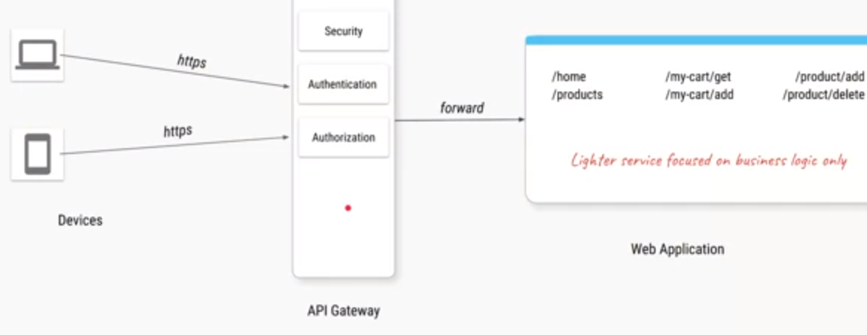

Feature#2 Separate and consolidate cross cutting concerns across microservices

* + Authentication
  + Authorization
  + SSL termination
  + DDoS protection / Throttling
  + Routing

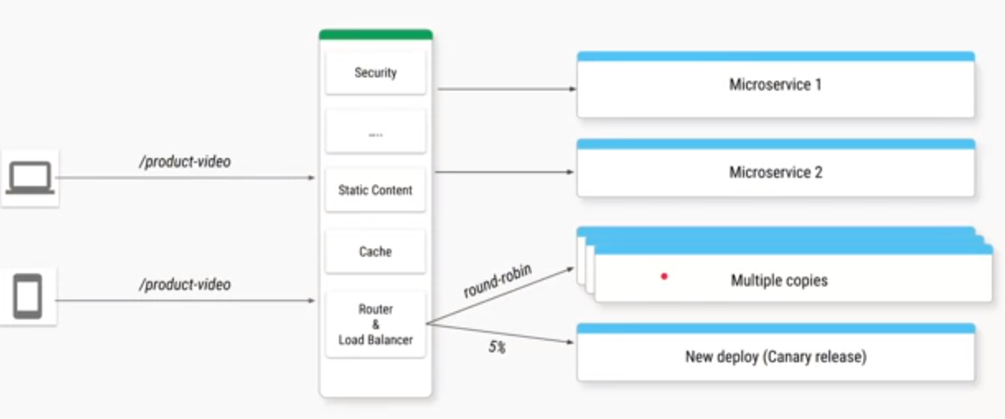

Feature#3 Replacing multiple clients calls with single API call

Also, some features of revers proxy

* + Serving static content
  + Caching responses

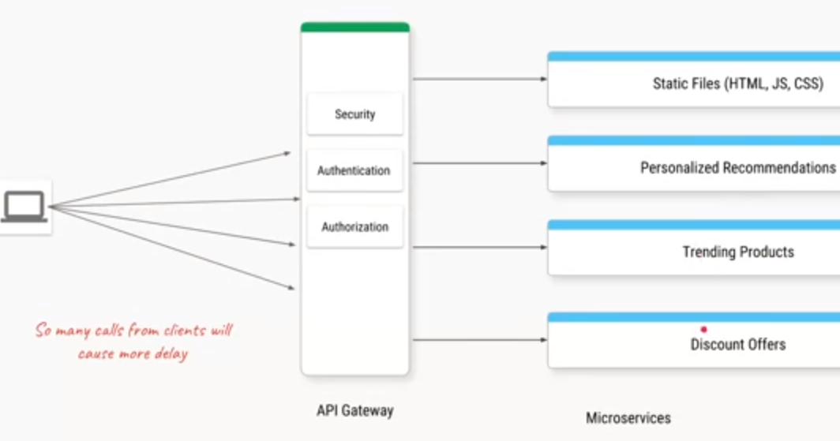

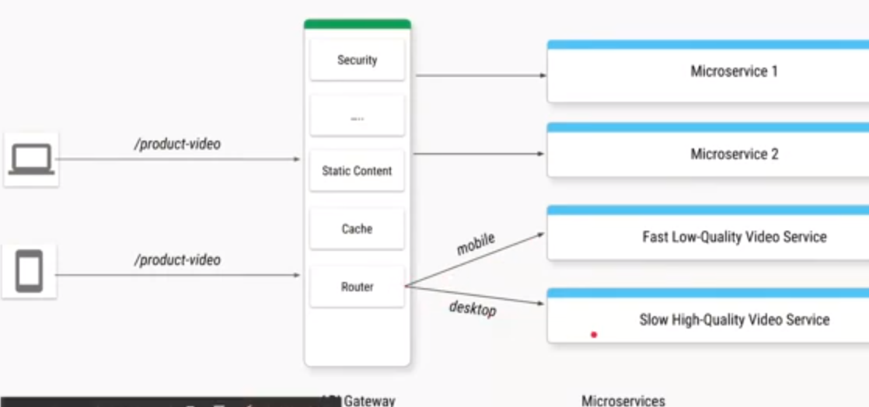

Feature4# Routing based on headers, paths and params etc.

Also, Some features of load balancer component

* + Load balancing
  + A/B testing
  + Canary releases

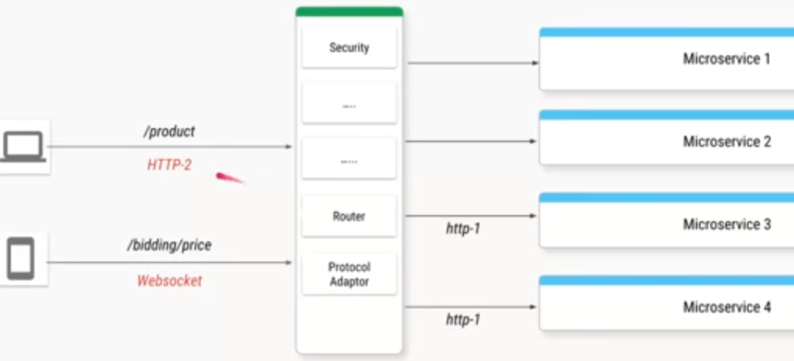

What is Azure Service Fabric?

Service fabric provides a platform that makes the process of developing microservices and managing application lifecycle easier

* + Produce application with faster time to market
  + Support windows/ linux, on-premises or other cloud
  + Provides the ability to scale up to a thousand machines

# Azure App Service?

Azure App Service is a fully managed "Platform as a Service" (PaaS) that integrates Microsoft Azure Websites, Mobile Services, and BizTalk Services into a single service, adding new capabilities that enable integration with on-premises or cloud systems. Azure App Service gives users several capabilities (see Figure 1):

* Provision and deploy Web and Mobile Apps in seconds
* Build engaging iOS, Android, and Windows apps
* Automate business processes with a visual design experience
* Integrate with "Software as a Service" (SaaS) applications (Office 365, Salesforce, Dynamics, OneDrive, Box, Dropbox, Twilio, Twitter, Facebook, Marketo, and so on) and on-premises applications

# Azure Key Vault

Azure Key Vault is a tool for securely storing and accessing secrets. A secret is anything that you want to tightly control access to, such as API keys, passwords, or certificates. A vault is a logical group of secrets

Azure Key Vault is a cloud service that provides a secure store for secrets. You can securely store keys, passwords, certificates, and other secrets. Azure key vaults may be created and managed through the Azure portal. In this QuickStart, you create a key vault, then use it to store a secret